

USEFUL JAPANESE DICTIONARY FOR VIETNAMESE

DETAIL DESIGN DOCUMENT

Class Design

**Project Code: UJD_VN**

**Document Code: UJD_VN_Class Design_v1.0_EN**

**Ha Noi, 26/06/2014**

Record of change

*A - Added M - Modified D – Deleted

|  |  |  |  |  |
| --- | --- | --- | --- | --- |
| **Effective Date** | **Changed Items** | **A* M, D** | **Change Description** | **New Version** |
| 26/06/2014 | Add new | A |  | v1.0 |
|  |  |  |  |  |
|  |  |  |  |  |
|  |  |  |  |  |
|  |  |  |  |  |
|  |  |  |  |  |
|  |  |  |  |  |
|  |  |  |  |  |
|  |  |  |  |  |
|  |  |  |  |  |
|  |  |  |  |  |
|  |  |  |  |  |

SIGNATURE PAGE

**ORIGINATOR:** Pham Tien Dat 26/06/2014

Developer

**REVIEWERS:** Le Dinh Nam 27/06/2014

Developer

**APPROVAL:** Nguyen Van Sang 27/06/2014

Supervisor

TABLE OF CONTENTS

1 Introduction 6

1.1 Purpose 6

1.2 Definitions, Acronyms and Abbreviations 6

2 Packages 7

2.1 User Package 8

2.1.1 Class diagram 8

2.1.2 Model_User class 9

2.1.3 UserController class 9

2.2 Admin Package 10

2.2.1 Class diagram 10

2.2.2 Model_User class 11

2.2.3 Model_Vocabulary class 12

2.2.4 Model_Grammar class 13

2.2.5 Model_Kanji class 14

2.2.6 Model_Sentence class 14

2.2.7 Model_Video class 15

2.2.8 Model_TrainingListening class 15

2.2.9 Model_ReadingDocument class 15

2.2.10 Model_Contact class 15

2.2.11 Model_Conversation class 15

2.2.12 Model_Test class 15

2.3 Vocabulary Package 16

2.3.1 Class diagram 16

2.3.2 Model_Vocabulary class 17

2.3.3 VocabularyController class 18

2.4 Grammar Package 18

2.4.1 Class diagram 18

2.4.2 Model_Grammar class 19

2.4.3 GrammarController class 20

2.5 Kanji Package 20

2.5.1 Class diagram 20

2.5.2 Model_Kanji class 21

2.5.3 KanjiController class 21

2.6 ReadingDocument Package 22

2.6.1 22

2.7 TrainingListening Package 22

2.7.1 Class diagram 22

2.7.2 Model_TraniningListening class 23

2.7.3 TrainingListeningController 23

2.8 Video Package 24

2.8.1 Class diagram 24

2.8.2 Model_Video class 25

2.8.3 VideoController 25

2.9 Contact Package 26

2.9.1 Class diagram 26

2.9.2 Model_Contact class 26

2.9.3 ContactController 27

2.10 Sentence Package 28

2.10.1 Class diagram 28

2.10.2 Model_Sentence class 29

2.10.3 SentenceController 29

2.11 Conversation Package 30

2.11.1 Class diagram 30

2.11.2 Model_Conversation class 31

2.11.3 ConversationController 31

2.12 Test Package 32

2.12.1 Class diagram 32

2.12.2 Model_Test class 33

2.12.3 TestController 34

3 MVC model 35

# Introduction

## Purpose

Useful Japanese Dictionary for Vietnamese class design document contains descriptions of all classes of the Useful Japanese Dictionary for Vietnamese system. It includes:

* Class diagrams that describe the static relation of all classes in the system.

## Definitions, Acronyms and Abbreviations

|  |  |  |
| --- | --- | --- |
| Abbreviations | Description | Comment |
| MVC | Model View Control model |  |

# Packages

|  |  |  |  |
| --- | --- | --- | --- |
| No | Package | Language | Description |
| 1. 01 | User | PHP | Store all information of User, or perform register, reset password. |
|  | Admin | PHP | Manage User, Vocabulary, Grammar , Kanji, ReadingDocument, TrainingListening, Video, Contact, Sentence, Conversation, Test. |
|  | Vocabulary | PHP | Store all information of Vocabulary. |
|  | Grammar | PHP | Store all information of Grammar. |
|  | Kanji | PHP | Store all information of Kanji. |
|  | ReadingDocumnet | PHP | Store all information of Document. |
|  | TrainingListening | PHP | Store all information of Listen. |
|  | Video | PHP | Store all information of Video. |
|  | Contact | PHP | Store all information of Contact ( Q&A, opinion). |
|  | Sentence | PHP | Store all information of Sentence. |
|  | Conversation | PHP | Store all information of Conversation. |
|  | Test | PHP | Store all information of Test( question, answer, tracking mark..). |

## User Package

### Class diagram

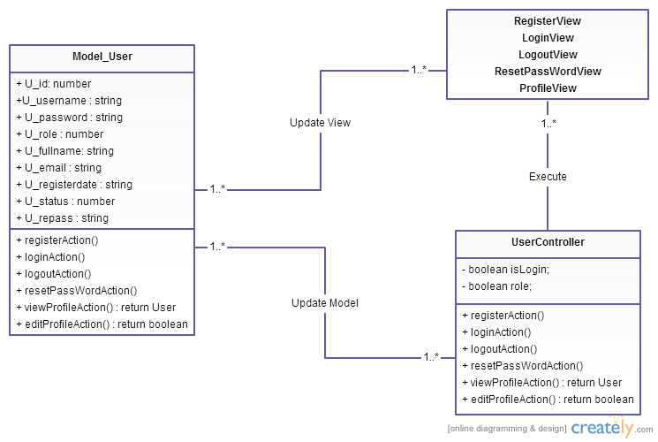

**Figure 1: Class diagram user package**

|  |  |  |
| --- | --- | --- |
| No | Class Name | Description |
| 1 | Model_User |  |
| 2 | UserController |  |

### Model_User class

#### Attributes

|  |  |  |  |  |  |
| --- | --- | --- | --- | --- | --- |
| No | Attribute | Type | Default | Note | Description |
| 1. 1 | U_id | Int |  | private |  |
|  | U_username | String |  | private |  |
|  | U_password | String |  | private |  |
|  | U_role | Int |  | private |  |
|  | U_fullname | String |  | private |  |
|  | U_email | String |  | private |  |
|  | U_registerdate | String |  | private |  |
|  | U_status | Number |  | private |  |
|  | U_repass | String | Null | Private |  |

#### Methods

|  |  |  |
| --- | --- | --- |
| No | Method | Description |
|  | registerAction() | Interact with database |
|  | loginAction() | Interact with database |
|  | logoutAction() | Interact with database |
|  | resetPasswordAction() | Interact with database |
|  | viewProfileAction() | Interact with database |
|  | editProfileAction() | Interact with database |

### UserController class

#### Attributes

|  |  |  |  |  |  |
| --- | --- | --- | --- | --- | --- |
| No | Attribute | Type | Default | Note | Description |
| 1 | Islogin | boolean |  |  | Check authentication |
| 2 | role | Int |  |  | Check role of user |

#### Methods

|  |  |  |
| --- | --- | --- |
| No | Method | Description |
|  | registerAction() | Register member |
|  | loginAction() | Login website |
|  | logoutAction() | Logout website |
|  | resetPasswordAction() | Reset password of user |
|  | viewProfileAction() | View profile user |
|  | editProfileAction() | Edit profile user |

## Admin Package

### Class diagram

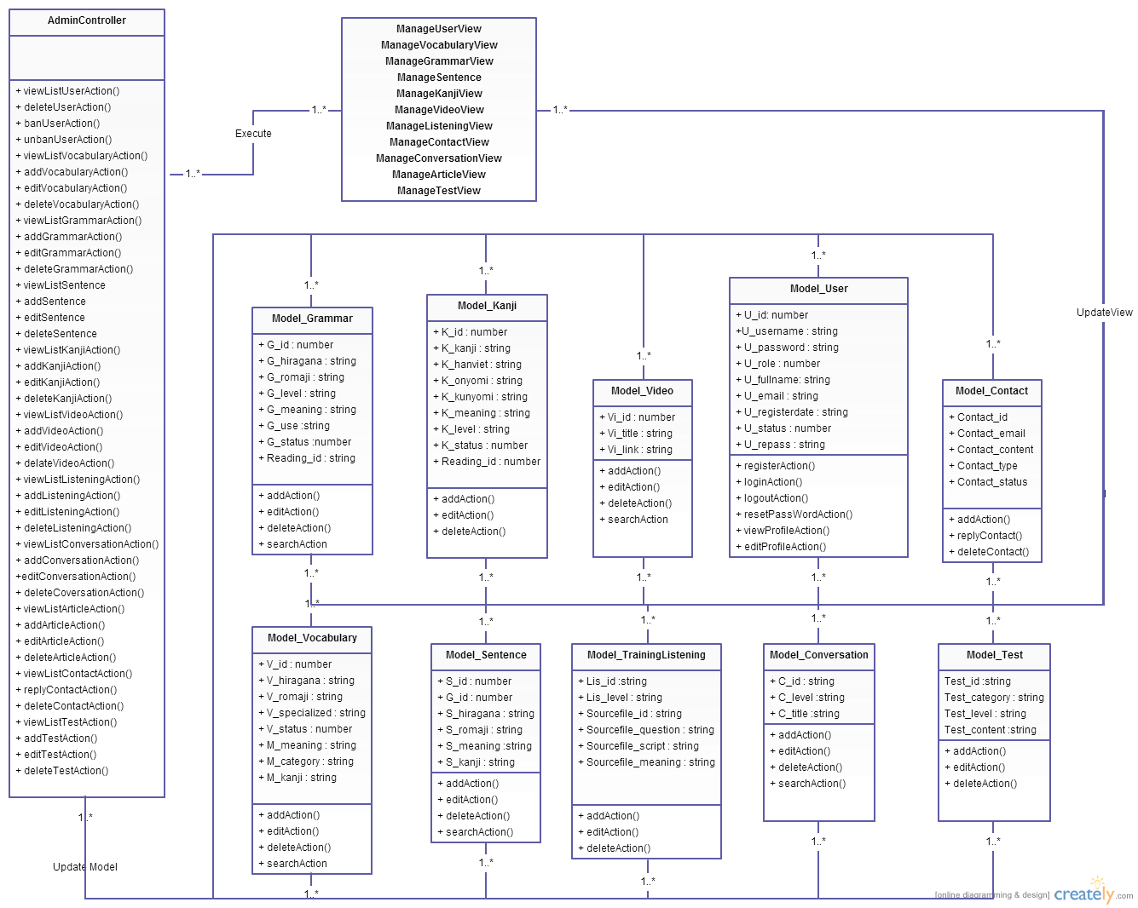

**Figure 2: Class diagram Admin package**

|  |  |  |
| --- | --- | --- |
| No | Class Name | Description |
| 1 | Model_User |  |
| 2 | Model_Vocabulary |  |
| 3 | Model_Grammar |  |
| 4 | Model_Kanji |  |
| 5 | Model_Sentence |  |
| 6 | Model_Video |  |
| 7 | Model_Contact |  |
| 8 | Model_TrainingListening |  |
| 9 | Model_ReadingDocument |  |
| 10 | Model_Conversation |  |
| 11 | Model_Test |  |

### Model_User class

#### Attributes

|  |  |  |  |  |  |
| --- | --- | --- | --- | --- | --- |
| No | Attribute | Type | Default | Note | Description |
| 1. 1 | U_id | Int |  | private |  |
|  | U_username | String |  | private |  |
|  | U_password | String |  | private |  |
|  | U_role | Int |  | private |  |
|  | U_fullname | String |  | private |  |
|  | U_email | String |  | private |  |
|  | U_registerdate | String |  | private |  |
|  | U_status | Number |  | private |  |
|  | U_repass | String | Null | Private |  |

#### Methods

|  |  |  |
| --- | --- | --- |
| No | Method | Description |
|  | registerAction() | Interact with database |
|  | loginAction() | Interact with database |
|  | logoutAction() | Interact with database |
|  | resetPasswordAction() | Interact with database |
|  | viewProfileAction() | Interact with database |
|  | editProfileAction() | Interact with database |

### Model_Vocabulary class

#### Attributes

|  |  |  |  |  |  |
| --- | --- | --- | --- | --- | --- |
| No | Attribute | Type | Default | Note | Description |
| 1. 1 | V_id | Int |  | private |  |
| 1. 2 | V_hiragana | String |  | private |  |
| 1. 3 | V_romaji | String |  | private |  |
| 1. 3 | V_specialized | String |  | private |  |
| 1. 3 | V_status | Int |  | private |  |
|  | M_id | Int |  | private |  |
|  | M_meaningvn | String |  | private |  |
|  | M_category | String |  | private |  |
|  | M_kanji | String |  | private |  |

#### Methods

|  |  |  |
| --- | --- | --- |
| No | Method | Description |
|  | addAction() | Interact with database |
|  | editAction() | Interact with database |
|  | deleteAction() | Interact with database |
|  | searchAction() | Interact with database |

### Model_Grammar class

#### Attributes

|  |  |  |  |  |  |
| --- | --- | --- | --- | --- | --- |
| No | Attribute | Type | Default | Note | Description |
| 1. 1 | G_id | Int |  | private |  |
| 1. 2 | G_hiragana | String |  | private |  |
| 1. 3 | G_romaji | String |  | Private |  |
| 1. 3 | G_level | String |  | private |  |
|  | G_meaning | String |  | private |  |
|  | G_use | String |  | private |  |
|  | G_status | Int |  | Private |  |
|  | Reading_id | String |  | private |  |

#### Methods

|  |  |  |
| --- | --- | --- |
| No | Method | Description |
|  | addAction() | Interact with database |
|  | editAction() | Interact with database |
|  | deleteAction() | Interact with database |
|  | searchAction() | Interact with database |

### Model_Kanji class

#### Attributes

|  |  |  |  |  |  |
| --- | --- | --- | --- | --- | --- |
| No | Attribute | Type | Default | Note | Description |
| 1. 1 | K_id | Int |  | private |  |
| 1. 2 | K_kanji | String |  | private |  |
| 1. 3 | K_hanviet | String |  | Private |  |
| 1. 3 | K_onyomi | String |  | private |  |
|  | K_kunyomi | String |  | private |  |
|  | K_meaning | String |  | private |  |
|  | K_level | String |  | private |  |
|  | K_status | String |  | private |  |
|  | Reading_id | String |  | private |  |

#### Methods

|  |  |  |
| --- | --- | --- |
| No | Method | Description |
|  | addAction() | Interact with database |
|  | editAction() | Interact with database |
|  | deleteAction() | Interact with database |

### Model_Sentence class

#### Attributes

#### Methods

### Model_Video class

#### Attributes

#### Methods

### Model_TrainingListening class

#### Attributes

#### Methods

### Model_ReadingDocument class

#### Attributes

#### Methods

### Model_Contact class

#### Attributes

#### Methods

### Model_Conversation class

#### Attributes

#### Methods

### Model_Test class

#### Attributes

#### Methods

## Vocabulary Package

### Class diagram

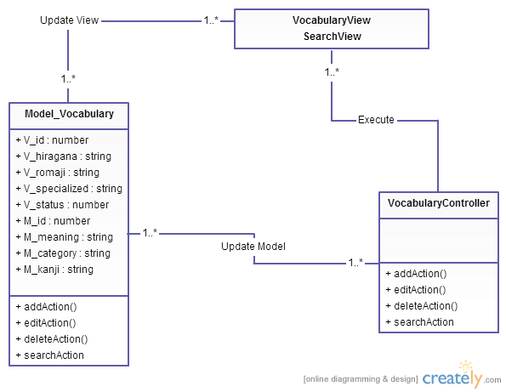

**Figure 3: Class diagram Vocabulary package**

|  |  |  |
| --- | --- | --- |
| No | Class Name | Description |
| 1 | Model_Vocabulary |  |
| 2 | VocabularyController |  |

### Model_Vocabulary class

#### Attributes

|  |  |  |  |  |  |
| --- | --- | --- | --- | --- | --- |
| No | Attribute | Type | Default | Note | Description |
| 1 | V_id | Int |  | private |  |
| 2 | V_hiragana | String |  | private |  |
| 3 | V_romaji | String |  | private |  |
| 4 | V_specialized | String |  | private |  |
| 5 | V_status | Int |  | private |  |
| 6 | M_id | Int |  | private |  |
| 7 | M_meaningvn | String |  | private |  |
| 8 | M_category | String |  | private |  |
| 9 | M_kanji | String |  | private |  |

#### Methods

|  |  |  |
| --- | --- | --- |
| No | Method | Description |
| 1 | addAction() | Interact with database |
| 2 | editAction() | Interact with database |
| 3 | deleteAction() | Interact with database |
| 4 | searchAction() | Interact with database |

### VocabularyController class

#### Attributes

|  |  |  |  |  |  |
| --- | --- | --- | --- | --- | --- |
| No | Attribute | Type | Default | Note | Description |
|  |  |  |  |  |  |

#### Methods

|  |  |  |
| --- | --- | --- |
| No | Method | Description |
|  | CreateAction() | Create vocabulary |
|  | editAction() | Edit vocabulary |
|  | deleteAction() | Delete vocabulary |
|  | searchAction() | Search vocabulary |

## Grammar Package

### Class diagram

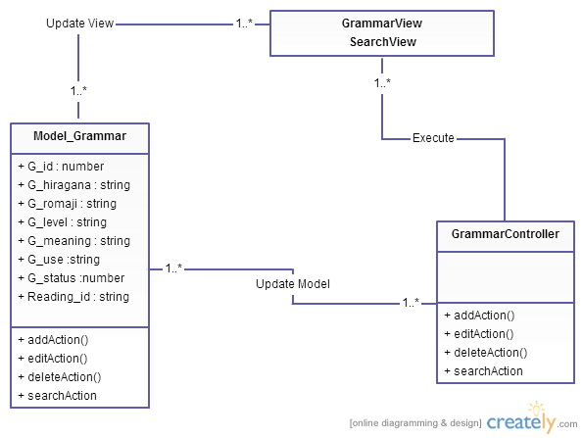

**Figure 4: Class diagram Grammar package**

|  |  |  |
| --- | --- | --- |
| No | Class Name | Description |
| 1 | Model_Grammar |  |
| 2 | GrammarController |  |

### Model_Grammar class

#### Attributes

|  |  |  |  |  |  |
| --- | --- | --- | --- | --- | --- |
| No | Attribute | Type | Default | Note | Description |
| 1. 1 | G_id | Int |  | private |  |
| 1. 2 | G_hiragana | String |  | private |  |
| 1. 3 | G_romaji | String |  | Private |  |
| 1. 3 | G_level | String |  | private |  |
|  | G_meaning | String |  | private |  |
|  | G_use | String |  | private |  |
|  | G_status | Int |  | Private |  |
|  | Reading_id | String |  | private |  |

#### Methods

|  |  |  |
| --- | --- | --- |
| No | Method | Description |
|  | addAction() | Interact with database |
|  | editAction() | Interact with database |
|  | deleteAction() | Interact with database |
|  | searchAction() | Interact with database |

### GrammarController class

#### Attributes

|  |  |  |  |  |  |
| --- | --- | --- | --- | --- | --- |
| No | Attribute | Type | Default | Note | Description |
|  |  |  |  |  |  |

#### Methods

|  |  |  |
| --- | --- | --- |
| No | Method | Description |
|  | addAction() | Create grammar |
|  | editAction() | Edit grammar |
|  | deleteAction() | Delete grammar |
|  | searchAction() | Search grammar |

## Kanji Package

### Class diagram

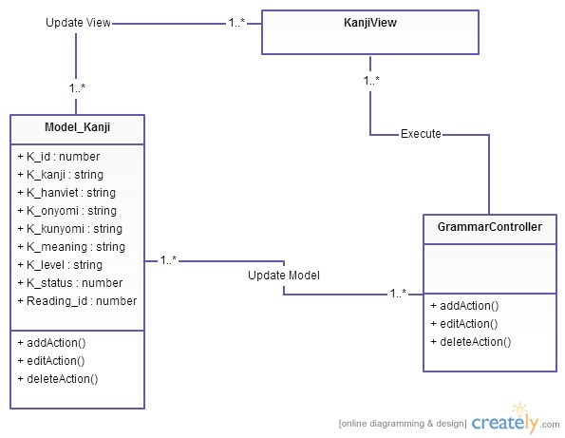

**Figure 5: Class diagram Kanji package**

|  |  |  |
| --- | --- | --- |
| No | Class Name | Description |
| 1 | Model_Kanji |  |
| 2 | KanjiController |  |

### Model_Kanji class

#### Attributes

|  |  |  |  |  |  |
| --- | --- | --- | --- | --- | --- |
| No | Attribute | Type | Default | Note | Description |
| 1. 1 | K_id | Int |  | private |  |
| 1. 2 | K_kanji | String |  | private |  |
| 1. 3 | K_hanviet | String |  | Private |  |
| 1. 3 | K_onyomi | String |  | private |  |
|  | K_kunyomi | String |  | private |  |
|  | K_meaning | String |  | private |  |
|  | K_level | String |  | private |  |
|  | K_status | String |  | private |  |
|  | Reading_id | String |  | private |  |

#### Methods

|  |  |  |
| --- | --- | --- |
| No | Method | Description |
|  | addAction() | Interact with database |
|  | editAction() | Interact with database |
|  | deleteAction() | Interact with database |

### KanjiController class

#### Attributes

|  |  |  |  |  |  |
| --- | --- | --- | --- | --- | --- |
| No | Attribute | Type | Default | Note | Description |
|  |  |  |  |  |  |

#### Methods

|  |  |  |
| --- | --- | --- |
| No | Method | Description |
|  | addAction() | Create kanji |
|  | editAction() | Edit kanji |
|  | deleteAction() | Delete kanji |

## ReadingDocument Package

### 

## TrainingListening Package

### Class diagram

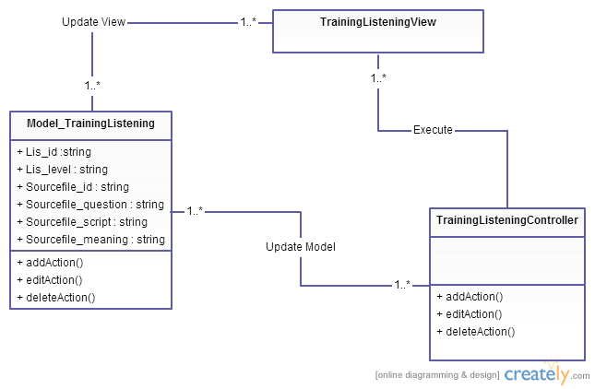

**Figure 7: Class diagram TrainingListening package**

|  |  |  |
| --- | --- | --- |
| No | Class Name | Description |
| 1 | Model_TrainingListening |  |
| 2 | TrainingListening Controller |  |

### Model_TraniningListening class

#### Attributes

|  |  |  |  |  |  |
| --- | --- | --- | --- | --- | --- |
| No | Attribute | Type | Default | Note | Description |
| 1. 1 | Lis_id | String |  | private |  |
| 1. 2 | Lis_level | String |  | private |  |
| 1. 3 | Sourcefile_id | String |  | Private |  |
| 1. 3 | Sourcefile_ question | String |  | private |  |
|  | Sourcefile_ script | String |  | private |  |
|  | Sourcefile_ meaning | String |  | private |  |

#### Methods

|  |  |  |
| --- | --- | --- |
| No | Method | Description |
|  | addAction() | Interact with database |
|  | editAction() | Interact with database |
|  | deleteAction() | Interact with database |

### TrainingListeningController

#### Attributes

|  |  |  |  |  |  |
| --- | --- | --- | --- | --- | --- |
| No | Attribute | Type | Default | Note | Description |
|  |  |  |  |  |  |

#### Methods

|  |  |  |
| --- | --- | --- |
| No | Method | Description |
|  | addAction() | Create Training Listening |
|  | editAction() | Edit Training Listening |
|  | deleteAction() | Delete Training Listening |

## Video Package

### Class diagram

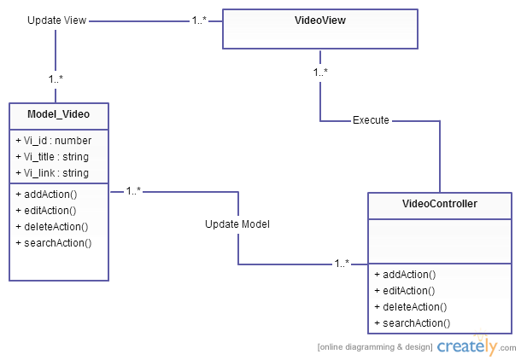

**Figure 8: Class diagram Video package**

|  |  |  |
| --- | --- | --- |
| No | Class Name | Description |
| 1 | Model_Video |  |
| 2 | VideoController |  |

### Model_Video class

#### Attributes

|  |  |  |  |  |  |
| --- | --- | --- | --- | --- | --- |
| No | Attribute | Type | Default | Note | Description |
| 1. 1 | Vi_id | Int |  | private |  |
| 1. 2 | Vi_title | String |  | private |  |
| 1. 3 | Vi_link | String |  | Private |  |

#### Methods

|  |  |  |
| --- | --- | --- |
| No | Method | Description |
|  | addAction() | Interact with database |
|  | editAction() | Interact with database |
|  | deleteAction() | Interact with database |
|  | searchAction() | Interact with database |

### VideoController

#### Attributes

|  |  |  |  |  |  |
| --- | --- | --- | --- | --- | --- |
| No | Attribute | Type | Default | Note | Description |
|  |  |  |  |  |  |

#### Methods

|  |  |  |
| --- | --- | --- |
| No | Method | Description |
|  | addAction() | Create Video |
|  | editAction() | Edit Video |
|  | deleteAction() | Delete Video |
|  | searchAction() | Search Video |

## Contact Package

### Class diagram

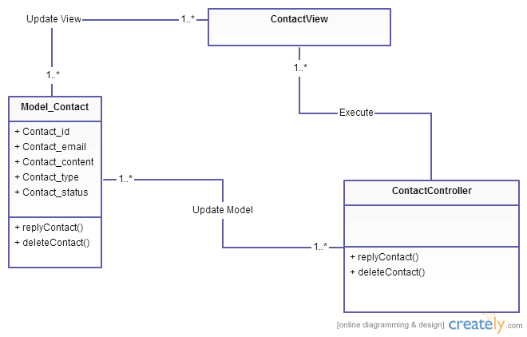

**Figure 9: Class diagram Contact package**

|  |  |  |
| --- | --- | --- |
| No | Class Name | Description |
| 1 | Model_Contact |  |
| 2 | ContactController |  |

### Model_Contact class

#### Attributes

|  |  |  |  |  |  |
| --- | --- | --- | --- | --- | --- |
| No | Attribute | Type | Default | Note | Description |
| 1. 1 | Contact_id | Int |  | private |  |
| 1. 2 | Contact_email | String |  | private |  |
| 1. 3 | Contact_content | String |  | private |  |
|  | Contact_type | String |  | private |  |
|  | Contact_ status | Int |  | private |  |

#### Methods

|  |  |  |
| --- | --- | --- |
| No | Method | Description |
|  | replyAction() | Interact with database |
|  | deleteAction() | Interact with database |

### ContactController

#### Attributes

|  |  |  |  |  |  |
| --- | --- | --- | --- | --- | --- |
| No | Attribute | Type | Default | Note | Description |
|  |  |  |  |  |  |

#### Methods

|  |  |  |
| --- | --- | --- |
| No | Method | Description |
|  | replyAction() | Edit Video |
|  | deleteAction() | Delete Video |

## Sentence Package

### Class diagram

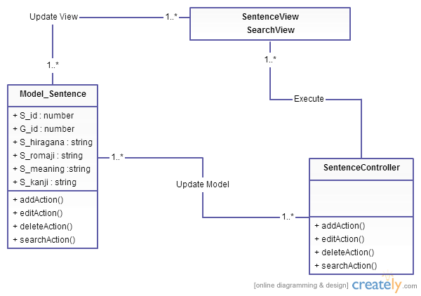

**Figure 10: Class diagram Sentence package**

|  |  |  |
| --- | --- | --- |
| No | Class Name | Description |
| 1 | Model_Sentence |  |
| 2 | SentenceController |  |

### Model_Sentence class

#### Attributes

|  |  |  |  |  |  |
| --- | --- | --- | --- | --- | --- |
| No | Attribute | Type | Default | Note | Description |
| 1. 1 | S_id | Int |  | private |  |
| 1. 2 | G_id | Int |  | private |  |
| 1. 3 | S_hiragana | String |  | private |  |
|  | S_romaji | String |  | private |  |
|  | S_meaning | String |  | private |  |
|  | S_kanji | String |  |  |  |

#### Methods

|  |  |  |
| --- | --- | --- |
| No | Method | Description |
|  | addAction() | Interact with database |
|  | editAction() | Interact with database |
|  | deleteAction() | Interact with database |
|  | seachAction() | Interact with database |

### SentenceController

#### Attributes

|  |  |  |  |  |  |
| --- | --- | --- | --- | --- | --- |
| No | Attribute | Type | Default | Note | Description |
|  |  |  |  |  |  |

#### Methods

|  |  |  |
| --- | --- | --- |
| No | Method | Description |
|  | addAction() | Create Sentence |
|  | editAction() | Edit Sentence |
|  | deleteAction() | Delete Sentence |
|  | seachAction() | Search Sentence |

## Conversation Package

### Class diagram

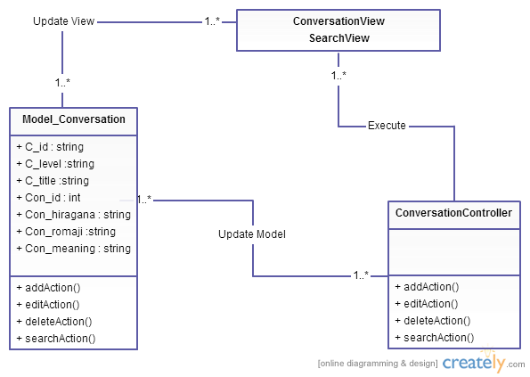

**Figure 11: Class diagram Conversation package**

|  |  |  |
| --- | --- | --- |
| No | Class Name | Description |
| 1 | Model_Conversation |  |
| 2 | Conversation Controller |  |

### Model_Conversation class

#### Attributes

|  |  |  |  |  |  |
| --- | --- | --- | --- | --- | --- |
| No | Attribute | Type | Default | Note | Description |
| 1. 1 | C_id | String |  | private |  |
| 1. 2 | C_level | String |  | private |  |
| 1. 3 | C_title | String |  | private |  |
|  | Con_id | Int |  | private |  |
|  | Con_hiragana | String |  | private |  |
|  | Con_romaji | String |  | private |  |
|  | Con_meaning | String |  | private |  |

#### Methods

|  |  |  |
| --- | --- | --- |
| No | Method | Description |
|  | addAction() | Interact with database |
|  | editAction() | Interact with database |
|  | deleteAction() | Interact with database |
|  | seachAction() | Interact with database |

### ConversationController

#### Attributes

|  |  |  |  |  |  |
| --- | --- | --- | --- | --- | --- |
| No | Attribute | Type | Default | Note | Description |
|  |  |  |  |  |  |

#### Methods

|  |  |  |
| --- | --- | --- |
| No | Method | Description |
|  | addAction() | Create Conversation |
|  | editAction() | Edit Conversation |
|  | deleteAction() | Delete Conversation |
|  | seachAction() | Search Conversation |

## Test Package

### Class diagram

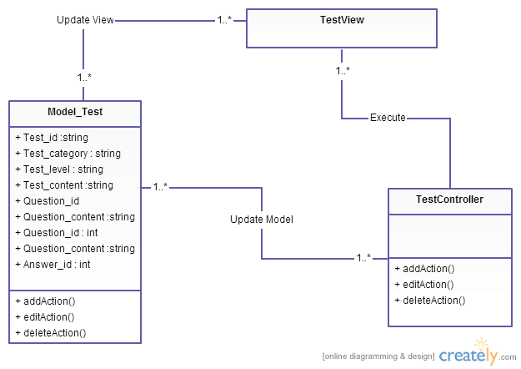

**Figure 12: Class diagram Test package**

|  |  |  |
| --- | --- | --- |
| No | Class Name | Description |
| 1 | Model_Test |  |
| 2 | Test Controller |  |

### Model_Test class

#### Attributes

|  |  |  |  |  |  |
| --- | --- | --- | --- | --- | --- |
| No | Attribute | Type | Default | Note | Description |
| 1. 1 | Test_id | String |  | private |  |
| 1. 2 | Test_category | String |  | private |  |
| 1. 3 | Test_level | String |  | private |  |
|  | Test_content | String |  | private |  |
|  | Question_id | String |  | private |  |
|  | Question_content | String |  | private |  |
|  | Question_id | Int |  | private |  |
|  | Question_content | String |  | private |  |
|  | Answer_id | Int |  | private |  |

#### Methods

|  |  |  |
| --- | --- | --- |
| No | Method | Description |
|  | addAction() | Interact with database |
|  | editAction() | Interact with database |
|  | deleteAction() | Interact with database |

### TestController

#### Attributes

|  |  |  |  |  |  |
| --- | --- | --- | --- | --- | --- |
| No | Attribute | Type | Default | Note | Description |
|  |  |  |  |  |  |

#### Methods

|  |  |  |
| --- | --- | --- |
| No | Method | Description |
|  | addAction() | Create Test |
|  | editAction() | Edit Test |
|  | deleteAction() | Delete Test |

# MVC model

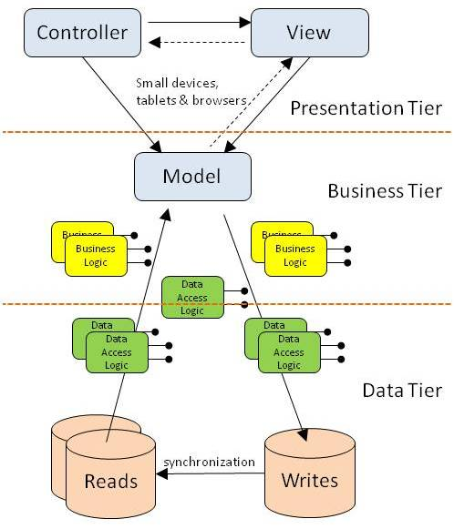

***Figure 6: MVC Model***